JetBlue BG November Promo Storefront AB test result Update as of 2017-11-29:

After resetting the configuration ID on Nov 24th, it’s now five days. The Test Storefront is so far generating a +4% lift in Revenue per Visitor over the Control Storefront. However, neither ATS nor Conversion reached the statistical significance. The promotion is ending Nov 30th; we will reset the configuration ID and restart the Storefront performance tracking during the baseline period.

1. The Revenue per Visitor of the Test Storefront was **+4%** higher than the Control Storefront.
2. The conversion rate of the Test Storefront was **+8% higher** than that of the Control Storefront
3. The ATS of the Test Storefront was **-3% lower** than that of the Control Storefront

You can find the report here,

<https://data.points.com/#/views/JetBlue_Oct25-Nov30Promo2017_Storefront_ABtestafterreset/Story>

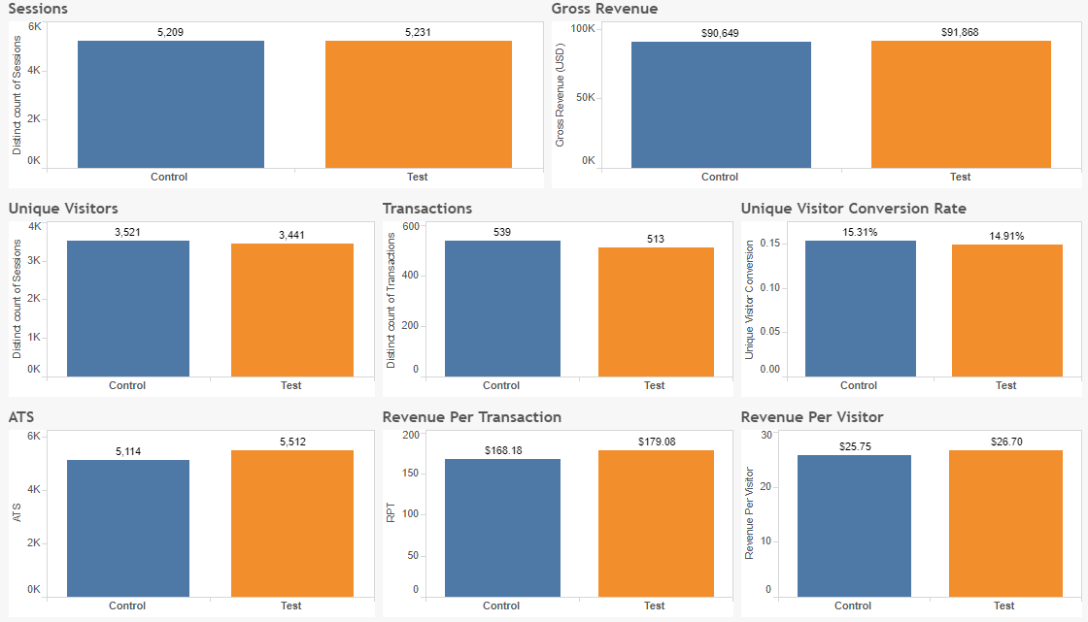

The entire Storefront test during promo ran from October 25th and November 29th for 34 days,

1. The Revenue per Visitor of the Test Storefront was **+4%** higher than the Control Storefront
2. The conversion rate of the Test Storefront was **+1% higher** than that of the Control Storefront
3. The ATS of the Test Storefront was **+3% higher** than that of the Control Storefront
4. Neither ATS nor Conversion reached statistical significance